|  |  |  |
| --- | --- | --- |
| Bangalore Shivacharan – CEO | David Hong – product manager | Nayanjeet Medhi |
| Jamey Money - User | Marguerite Rogers - User | Jaychand |
| Steve Levis - User |  |  |

Use Cases.

1. Users need a credible data source to obtain information about adverse events of a drug(s).

2. Users would like to know if they are vulnerable to these drugs. Does the drug affect a particular age group or sex more than others? Is there any adverse effect of the combination of drugs that the user is taking?

3. What has caused the ‘spikes’ in the adverse events? Can this be explained by some other occurrences?

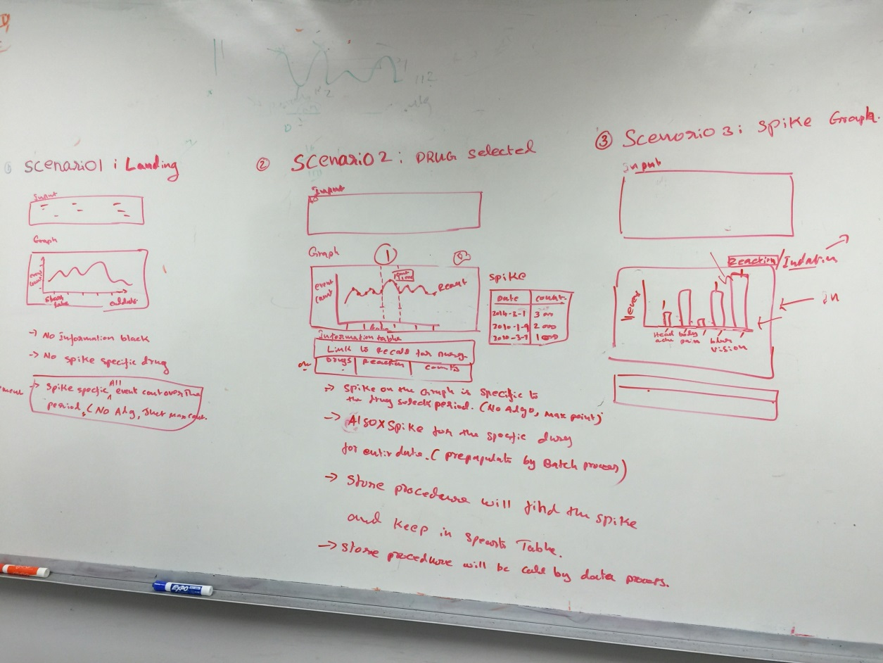

User Interface v1.

1. User should be able to filter on Drug, Age, Sex.

2. The interface should draw a graph on Adverse Events for the criteria selected above.

3. Correlate Adverse events data to Recall data.

The UI was refined further and sent to the devOps team to create HTML Mockups.

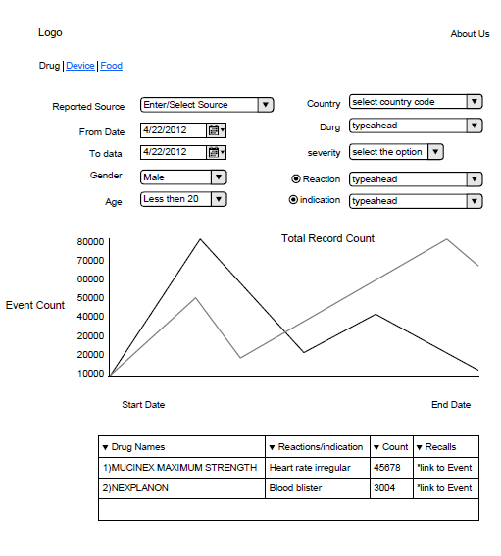

User Interface v2.

Comments.

1. Add a table to show the spikes over the entire period of time.